The effect of Batch Normalization on training stability
Steven Bontius 1 – 3 – 2026
Hypothesis
Batch Normalization (BN) enables stable training at higher learning rates, while networks without BN will have trouble converging or might even diverge. This is expected because BN smooths the loss landscape by normalizing activations at each layer.
Experiment Deisgn
he experiment tests BN vs no-BN across a wide learning rate range using a fixed 4-layer CNN (Filters 32, 64, 128, 256 and Fully Connected layer of 128 units) trained on FashionMNIST.
SGD was chosen deliberately over Adam, as the latter's internal scaling masks the learning rate sensitivity and more or less makes BN redundant as a stabilizer. No learning rate scheduler was used to ensure the sampled learning rate remained constant throughout the run. Early stopping was also disabled in order to see the effect on converging. Both learning rates were tested with and without BN.
Batch size = 64
Number of epochs = 30
Training steps: 100
Validation steps: 100
Learning rates = [1e-4, 3e-4, 1e-3, 3e-3, 1e-2, 3e-2, 1e-1, 3e-1, 1.0]
Loss function = CrossEntropyLoss
The search strategy was initially Bayesian optimization (Tree-structured Parzen Estimator (TPE)). However, during the runs it became clear that TPE was actively working against the experiment. After some failed high learning rate trials, the optimizer learned to avoid that region. That meant that the failure zone the experiment was designed to expose was never properly sampled. Therefore, a full grid search was performed over the learning rates crossed with both BN conditions.
Results
The results do not support the hypothesis. Across the full learning rate range, both BN and no-BN models performed nearly identical. Three regions appear to be visable in the plots:
Low learning rate zone: At learning rates below 3e-4, models show lower accuracy and higher validation loss because 30 epochs are insufficient for convergence at such small step sizes.
Stable zone: Between 1e-3 and 3e-2, both conditions reach peak performance of 0.83 to 0.87 accuracy with no meaningful difference between them.
Degradation and collapse zone: Above 1e-1, performance degrades for both conditions. Notably, BN models showed slightly earlier degradation in this region, contrary to the hypothesis. Above 3e-1 both conditions collapse to approximately 0.10 accuracy, equivalent to random guessing on a 10-class problem, consistent with the theoretical cross-entropy baseline of log(10) ≈ 2.3.
Conclusion
The hypothesis is not supported. BN did not provide measurable stability advantages. The most likely explanation is that the chosen architecture is too shallow and the dataset too simple. The stabilizing effect of BN is documented for larger networks such as ResNets and harder image sets. A further exploration with larger nets and harder sets is recommended.

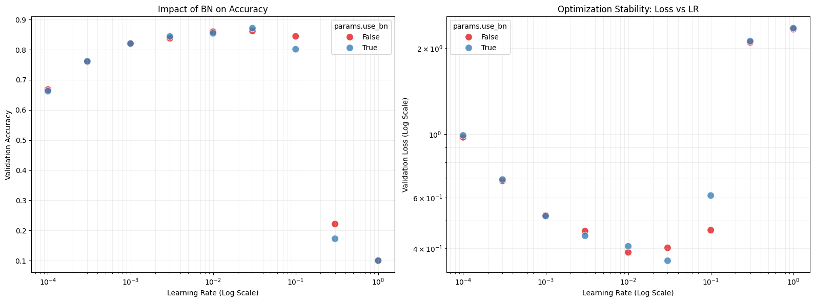
Fig 1. Accuracy and test loss

